Vietnam opens free stem cell bank
Hanoi - Saturday, September 27, 2014 23:21
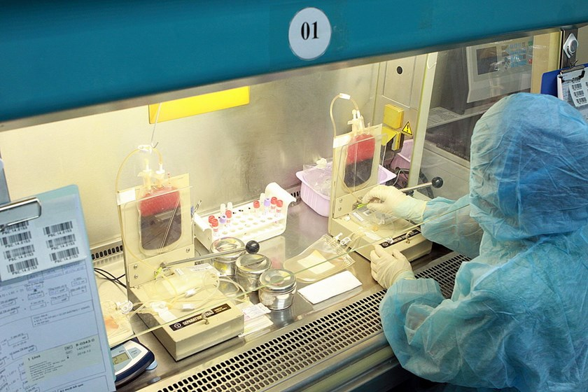Umbilical cord blood is stored at a community stem cell bank at the Central Hematology and Blood Transfusion Institute in Hanoi. Photo: Duong Ngoc
A Hanoi hematology institute has opened Vietnam’s first stem cell bank using umbilical cord donations.
The Central Institute of Hematology and Blood Transfusion began developing the bank in May in cooperation with Hanoi's Ob-Gyn Hospital.
The bank gathers and stores donations of umbilical cords for the purposes of treating blood conditions and diseases.
Vietnam has several other umbilical cell banks but "depositors" usually pay fees of roughly VND25 million ($1,180) per year.
Doctor Nguyen Anh Tri, head of the institute, said the umbilical cord cells can be used in compatible patients to treat malignant blood diseases that require stem cell transplants.
Leukemia patients, for example, have seen remarkable recoveries from the process.
Tri said the cords are carefully selected.
The institute sends experts to the Hanoi Ob-Gyn Hospital every day to collect the best-quality cords from over 100 deliveries there, with the mothers’ permission.
“The cords would otherwise be discarded,” he said. “But thanks to advanced technology, they can provide treatment for dangerous diseases.”
Stronger cords provide more blood and more stem cells, he said, adding that the cells can be stored for 15 to 17 years.
Suitable cords yield between 160 to 280 milligrams of blood.
Donor mothers must test negative for sexually transmitted diseases, hepatitis B and C, HIV, diabetes, high blood pressure, cancer and autoimmune disorders.
Donor mothers and their babies must also be fever and infection-free at the time of delivery.
Doctors said the extraction costs around VND15-20 million (US$708-943) and patients in need of the stem cells only have to cover that cost and other technical fees, if any.
“But in cases where the stem cells are needed by donating mothers or their family members, the patients don’t have to pay,” Tri said.
He said a similar bank in japan maintains 3,000 stem cell deposits and treats around 10 patients a month.
Stem cells are present in all parts of the body and account for 1 percent of the cells but determine the survival of the other 99 percent.
The transplant procedure involves injecting them into damaged parts of the body so they can develop new neurological cells to replace damaged cells or reactivate them, doctors said.
Other than the umbilical cords, stem cells can be extracted from bone marrow, but not all donors are suitable for such extractions.
Bach Quoc Khanh, deputy head of the institute, said they have successfully used stem cells to cure nine patients of severe blood diseases.
Some have already recovered and are leading normal lives at home.
Vietnam has used stem cell transplants to treat blood cancer, marrow tumors and other marrow disorders like paralysis.
Hanoi doctors treated a baby with cerebral palsy using stem cells last March.
International experts are studying their chances of curing autism, diabetes, Alzheimer, Parkinson, and strokes with the technology.

